Super/Subtype, Step Dimension, Dashboard II

Name: Swati Sharma

1. Comparing to other bank accounts, Checking accounts allows ATM withdrawal and deposit, money access via debit card and checks, and online money transfer. In addition to analyze the ending balance and the total of transactions per month. Users also would like to query the total withdraw amount and deposit amount, online money transfer, total frequency of debit card usage per month.

(1). Given the DimAccount and Monthly Periodical Fact Table, create a subtype dimension: DimCheckingAccount, and a subtype Fact Table.

(2) Customer 1 opened his checking account (A01, account number: 9915) on 12/1/2022. He’s using a debit card that connecting to his account ending with 2457. His ending balance of his checking account is $5000 in January, 2023. In February 2023, Customer 1 (C01) made 50 transactions, deposited $10000, withdrew $6000, made 3 times of debit card usage, transferred $3000 to a friend. Use this information to populate a record in the above 4 tables.

DimAccount (supertype dimension)

|  |  |  |
| --- | --- | --- |
| Column Name | Description | Keys |
| AccountID | Surrogate key | PK |
| AccountNumber |  | NK |
| Open Date |  |  |

Monthly Periodical Fact Table (supertype fact table)

|  |  |  |
| --- | --- | --- |
| Column Name | Description | Keys |
| End Date Key |  | FK |
| Account Key |  | FK |
| Customer Key |  | FK |
| Ending Balance |  |  |
| Total Number of Transactions |  |  |

DimCheckingAccount (subtype)

|  |  |  |
| --- | --- | --- |
| Column Name | Description | Keys |
| AccountID | Surrogate key | PK |
| AccountNumber |  | NK |
| Open Date |  |  |
| Debit Card Number |  |  |
| Check Sequence Number |  |  |
| Online transfer username |  |  |

Checking Account Snapshot Fact Table (subtype)

|  |  |  |
| --- | --- | --- |
| Column Name | Description | Keys |
| End Date Key |  | FK |
| Account Key |  | FK |
| Customer Key |  | FK |
| Ending Balance |  |  |
| Total Number of Transactions |  |  |
| Total Withdraw Amount |  |  |
| Total Deposit Amount |  |  |
| Online Money Transfer Amount |  |  |
| Total Debit Card Usage |  |  |

DimAccount (supertype dimension)

|  |  |
| --- | --- |
| Column Name | Value |
| AccountID | A01 |
| AccountNumber | 9915 |
| Open Date | 12/1/22 |

DimCheckingAccount (subtype)

|  |  |
| --- | --- |
| Column Name | Value |
| AccountID | A01 |
| AccountNumber | 9915 |
| Open Date | 12/1/2022 |
| Debit Card Number | 2457 |
| Check Sequence Number |  |
| Online transfer username |  |

Monthly Periodical Fact Table (supertype fact table)

|  |  |
| --- | --- |
| Column Name | Value |
| End Date Key | 2/28/2022 |
| Account Key | A01 |
| Customer Key | C01 |
| Ending Balance | $6000 |
| Total Number of Transactions | 50 |

Checking Account Snapshot Fact Table (subtype)

|  |  |
| --- | --- |
| Column Name | Value |
| End Date Key | 2/28/2022 |
| Account Key | A01 |
| Customer Key | C01 |
| Ending Balance | $6000 |
| Total Number of Transactions | 50 |
| Total Withdraw Amount | $6000 |
| Total Deposit Amount | $10000 |
| Online Money Transfer Amount | $3000 |
| Total Debit Card Usage | 3 |

2. Consider the following customer, page and step dimensions. Populate the fact table to fully capture the 2 web interactions below.



**Figure 1. CustomerA Interaction**



**Figure 2. Customer B interaction**

|  |  |  |  |  |  |  |  |  |  |  |  |  |  |  |  |  |  |  |  |
| --- | --- | --- | --- | --- | --- | --- | --- | --- | --- | --- | --- | --- | --- | --- | --- | --- | --- | --- | --- |
| DimCustomer Table   |  |  | | --- | --- | | CustomerKey | CustomerName | | 1 | CustomerA | | 2 | CustomerB | | DimPage Table   |  |  | | --- | --- | | PageKey | PageName | | 1 | BingRef | | 2 | HomePage | | 3 | SearchPage | | 4 | ProductPage | | 5 | PurchasePage | |

DimStep

|  |  |  |  |
| --- | --- | --- | --- |
| StepKey | TotalSteps | ThisStep | StepsToEnd |
| 1 | 1 | 1 | 0 |
| 2 | 2 | 1 | 1 |
| 3 | 2 | 2 | 0 |
| 4 | 3 | 1 | 2 |
| 5 | 3 | 2 | 1 |
| 6 | 3 | 3 | 0 |
| 7 | 4 | 1 | 3 |
| 8 | 4 | 2 | 2 |
| 9 | 4 | 3 | 1 |
| 10 | 4 | 4 | 0 |

FactTable

|  |  |  |  |
| --- | --- | --- | --- |
| CustomerKey | PageKey | StepKey | Fact1 (Leave Empty) |
| 1 | 2 | 7 |  |
| 1 | 3 | 8 |  |
| 1 | 4 | 9 |  |
| 1 | 5 | 10 |  |
| 2 | 1 | 4 |  |
| 2 | 4 | 5 |  |
| 2 | 5 | 6 |  |

3. Create Advanced Filter:

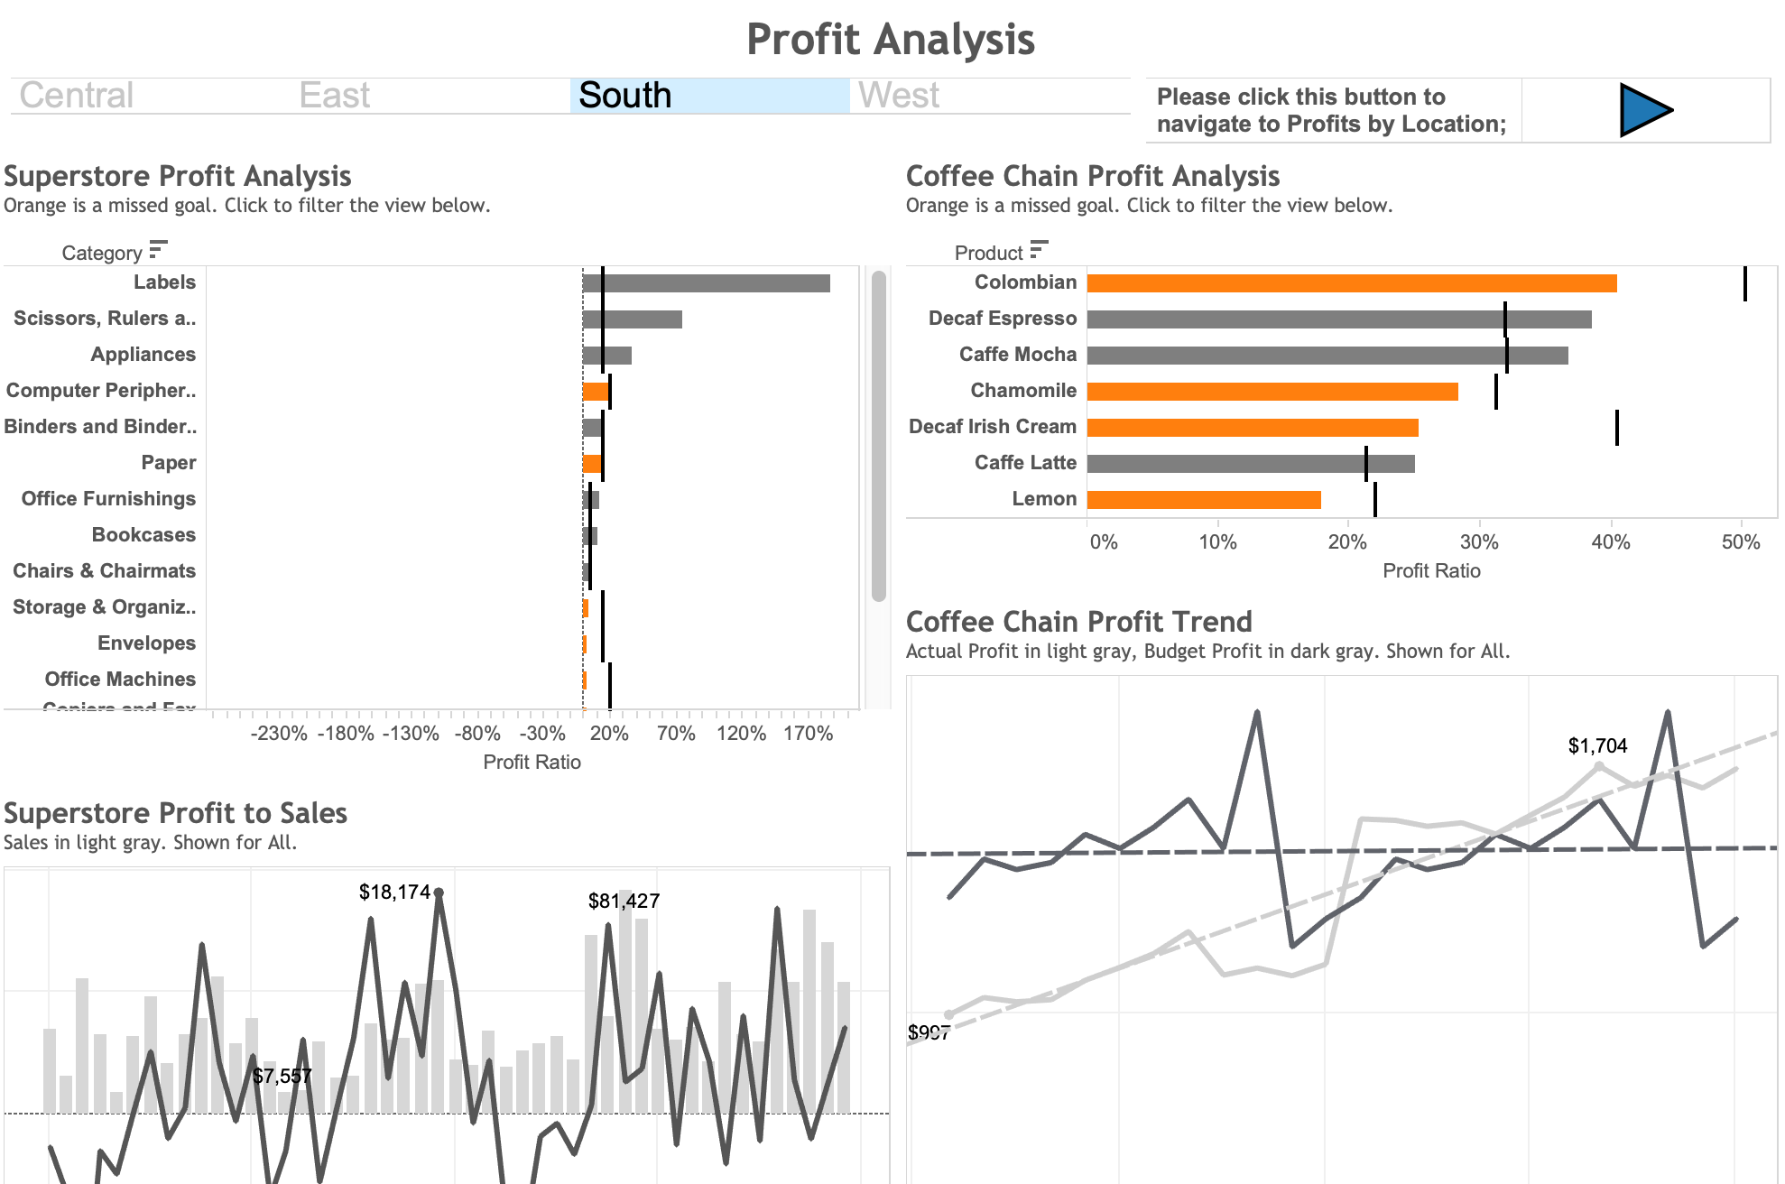

1. Create a region selection view for filter;

1. Use the region selection as the filter to add a filter action, that allows it not only filter superstore, but also coffee shop analysis;

1. Create button navigation views for future linking to Profits by Location, and linking back to Profit Analysis;

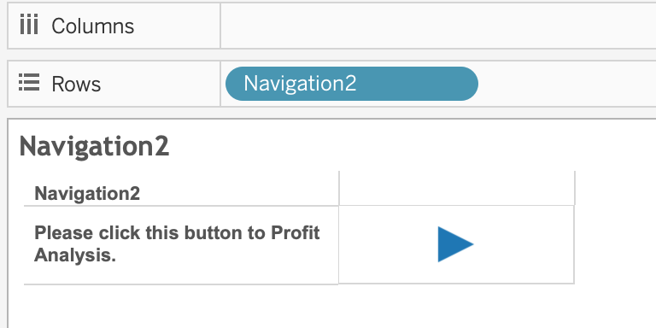

1. Use the button navigation as the filter to add a filter action, that allows to navigate to other dashboards;

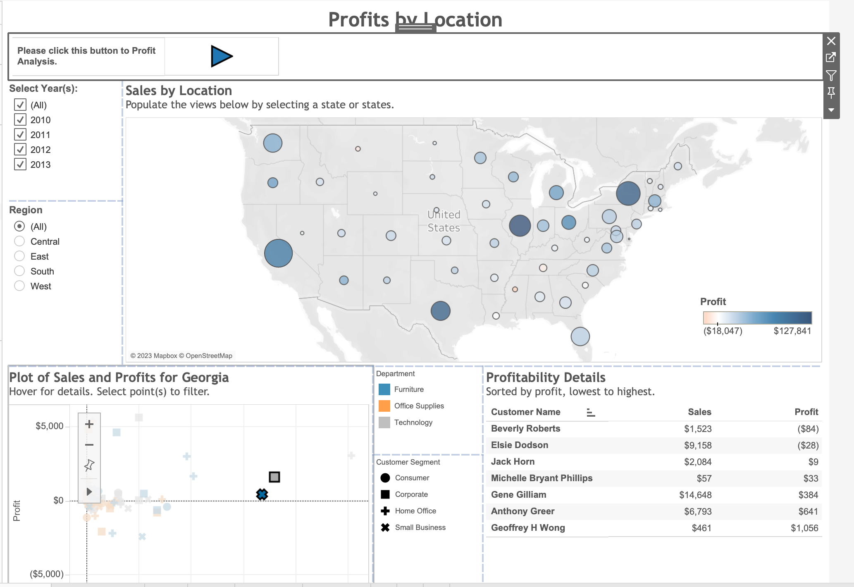

~~4. Swapping Sheets and Refining the Layout~~

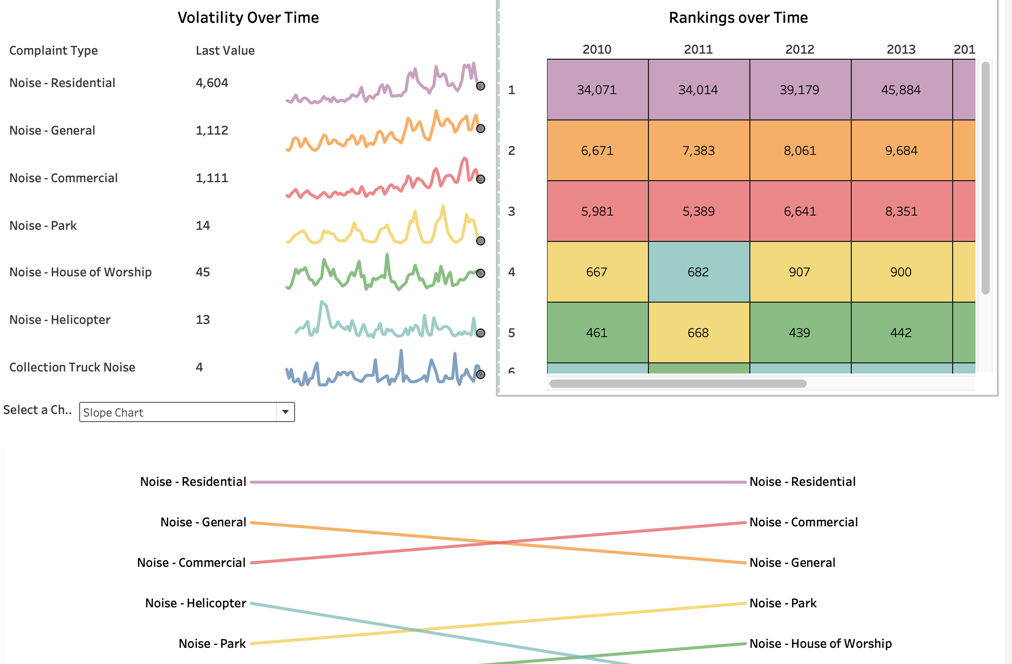

a. Create a parameter for swapping the slope, bump and control charts in the dashboard:

b. Create a calculated filed based on the parameter.

c. Use the calculated field as a filter for each swapped view; show the parameter control.

d. Drag the swapped views into the dashboard, and hide their titles; Remove all the other legends and filters;

5. Adding Context to Dashboard Filter Actions

For the main markets that use Superstore, you want to help users see only the top 25 cities and the top 10 products for sales. Use Top N filters to limit the view results. Then, use dashboard filter actions to filter all views by Market and the top product names by city.

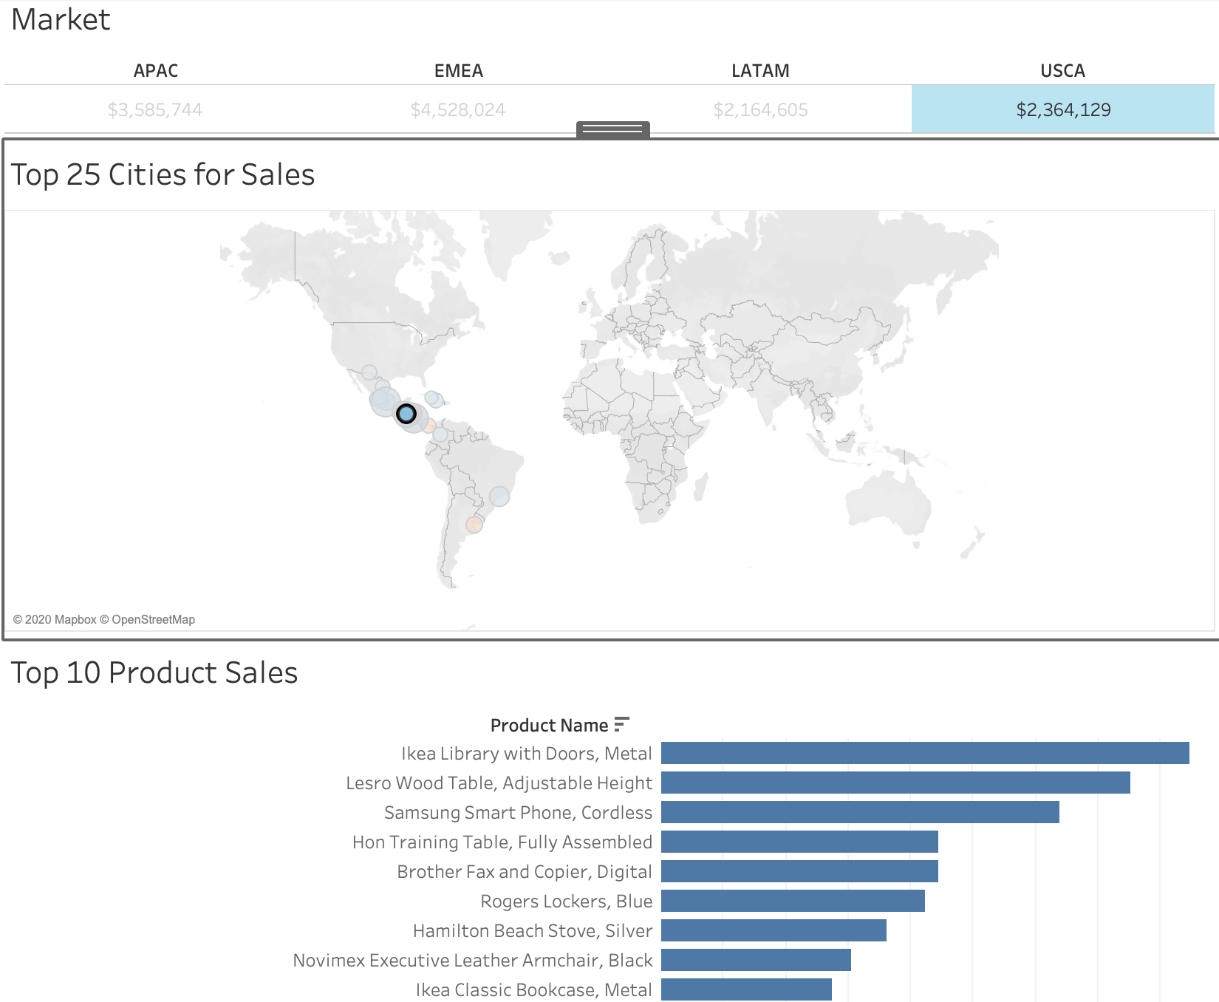

a. On the top 10 Product Sales worksheet, add a filter for the top 10 Product Names by Sales;

b. On the top 25 Cities for Sales worksheet, add a filter for the City and State field for top 25 by Sales.

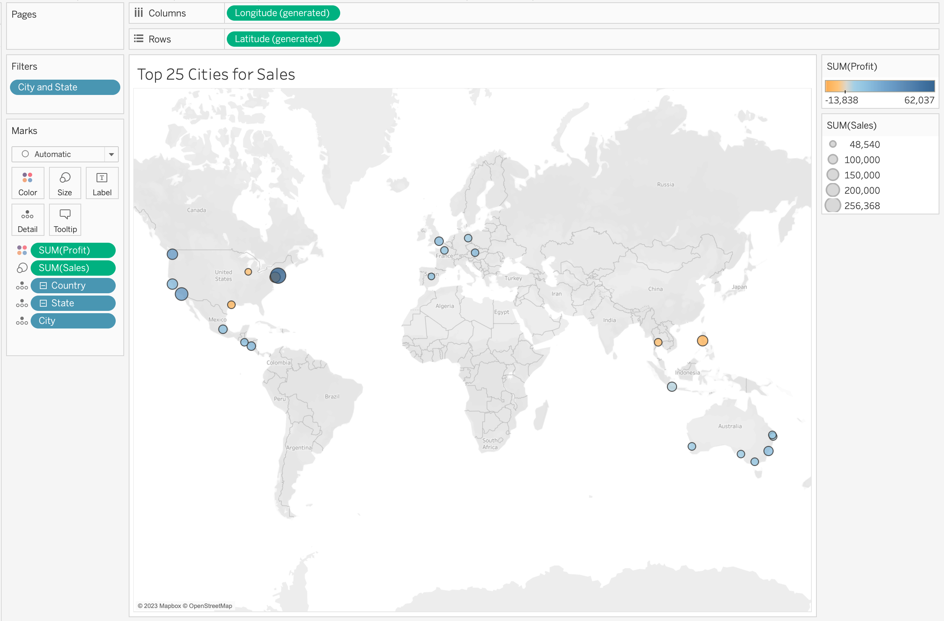

c. On the Worldwide Sales dashboard, use the Market sheet as a filter, then test it to observe the results.

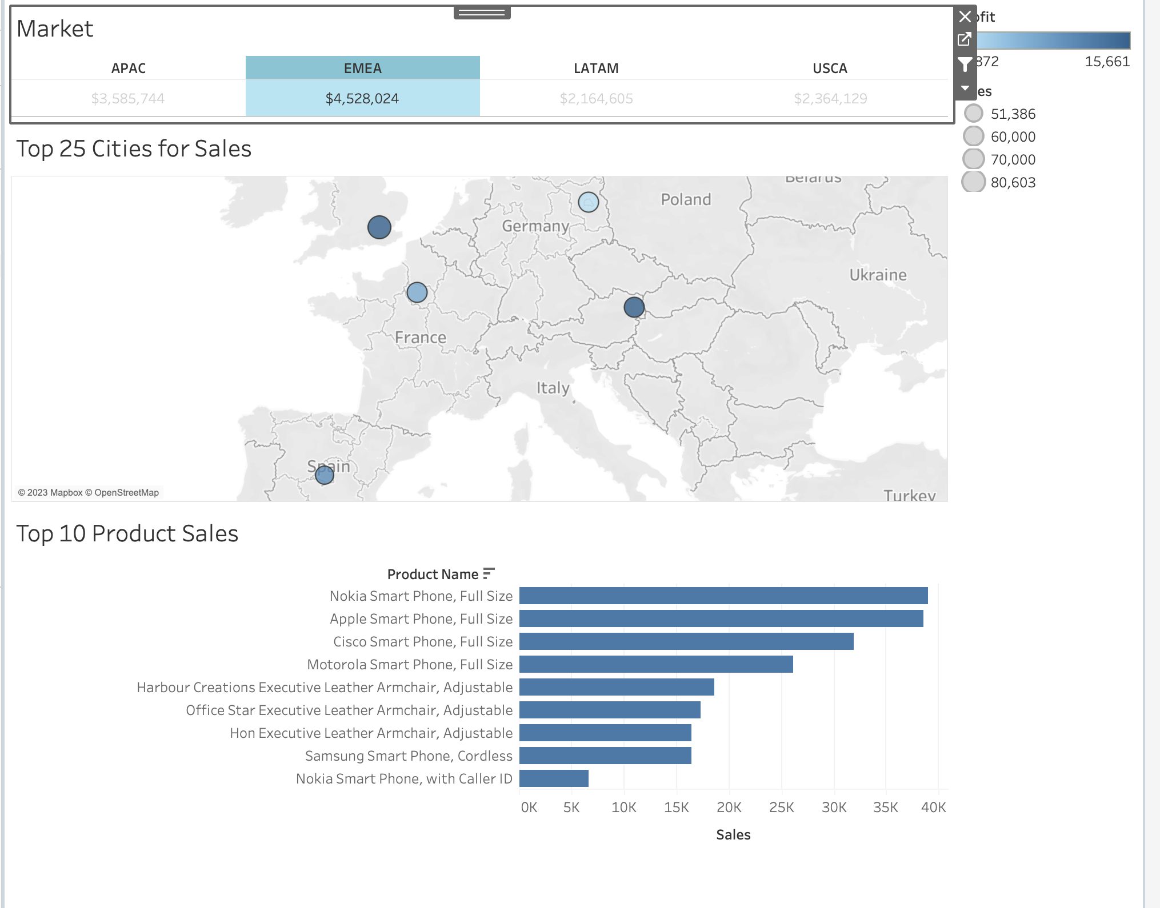

d. Generate a filter using Market as the source, and top 25 cities for sales as the target; Use city as the context to the filter.

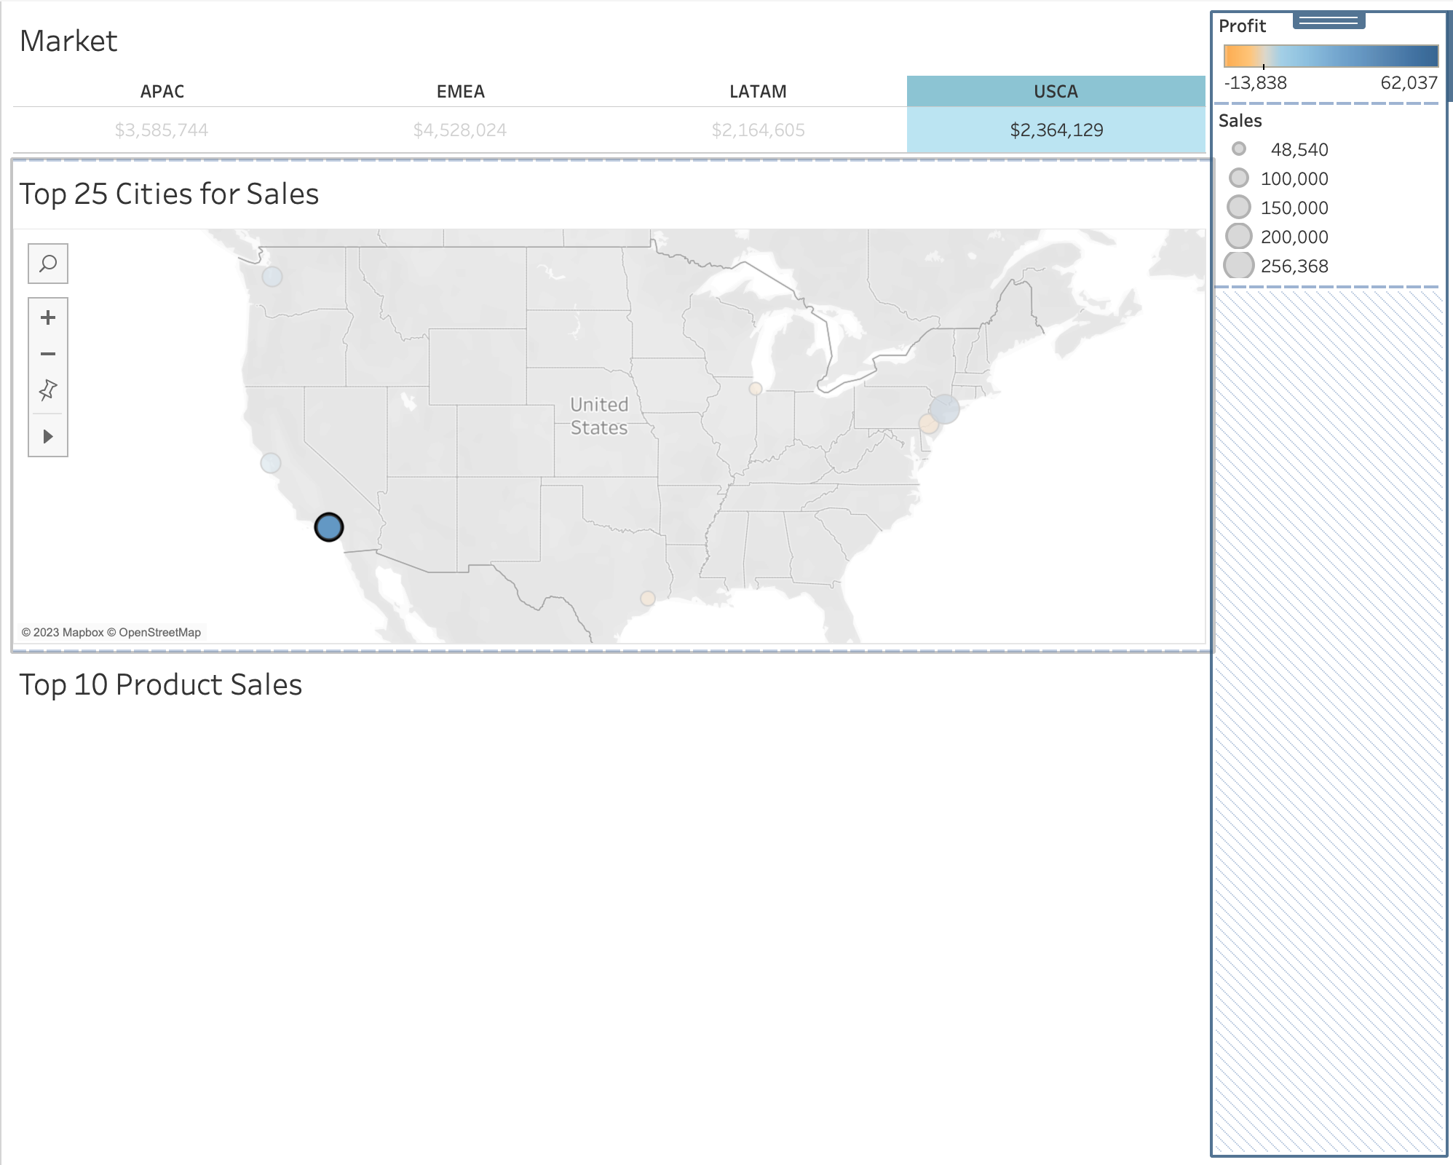

e. Generate a filter using Top 25 cities for sales as the source, and top 10 product for sales as the target; Use product name as the context to the filter.

